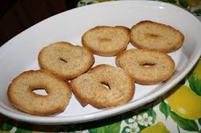
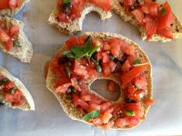
Italian freselle salad

Ingredients

- 1-2 disks
- A few fresh tomatoes, sliced
- 50g oregano
- a generous pinch of salt
- 1-2 teaspoons capers
- some black olives
- 1 can tuna in oil
- salt
- Olive oil
Instructions
- Pass the freselle under running water for 1 minute to soften them, then shake off the excess water. Add a spoon of olive oil on the freselle.
- Drain tuna in oil well and divide it into small pieces with a fork.
- To prepare the salad: in a bowl, mix the sliced tomatoes, tuna and capers with a bit of olive oil. Add the black olives.Sprinkle in the salt.
- Mix well and place on the top of the freselle.

They are typically made of white flour or of whole wheat flour. They are shaped like a large disk with a hole for a practical reason: in the past they were tucked in a rope that was then knotted to form a necklace. Easy to hang, transport and store. A “travelling bread” that fishermen used to bathe in seawater and consume during their long fishing trips.
Freselle are incredibly tasty, especially when seasoned with extra virgin olive oil. Also they make a quick, healthy, low fat meal. In Naples we use it as a “base” for salads.

